EX NO: 7
CALCULATION AND VERIFICATION OF FREQUENCY DEVIATION AND MODULATION INDEX OF FM SIGNALS USING MATLAB SIMULATION
Objectives:
1. To generate a Frequency Modulated (FM) signal in MATLAB using specified carrier and
message signal parameters.
Programming Code:
clc;
clear;
close all;

% Parameters
Am = 1; % Message signal amplitude
Ac = 2; % Carrier signal amplitude
fm = 100; % Message frequency in Hz
fc = 1000; % Carrier frequency in Hz
beta = 5; % Modulation index

% Time vector
fs = 100000; % Sampling frequency
t = 0:1/fs:0.02; % Time duration

% Message signal
m = Am * cos(2*pi*fm*t);

% Carrier signal
c = Ac * cos(2*pi*fc*t);

% Frequency Modulated signal
s = Ac * cos(2*pi*fc*t + beta*sin(2*pi*fm*t));

% Plot signals
figure;

subplot(3,1,1);
plot(t,m);
title('Message Signal');
xlabel('Time (s)');
ylabel('Amplitude');
grid on;

subplot(3,1,2);
plot(t,c);
title('Carrier Signal');
xlabel('Time (s)');
ylabel('Amplitude');
grid on;

subplot(3,1,3);
plot(t,s);
title('Frequency Modulated (FM) Signal');
xlabel('Time (s)');
ylabel('Amplitude');
grid on;
OUTPUT:
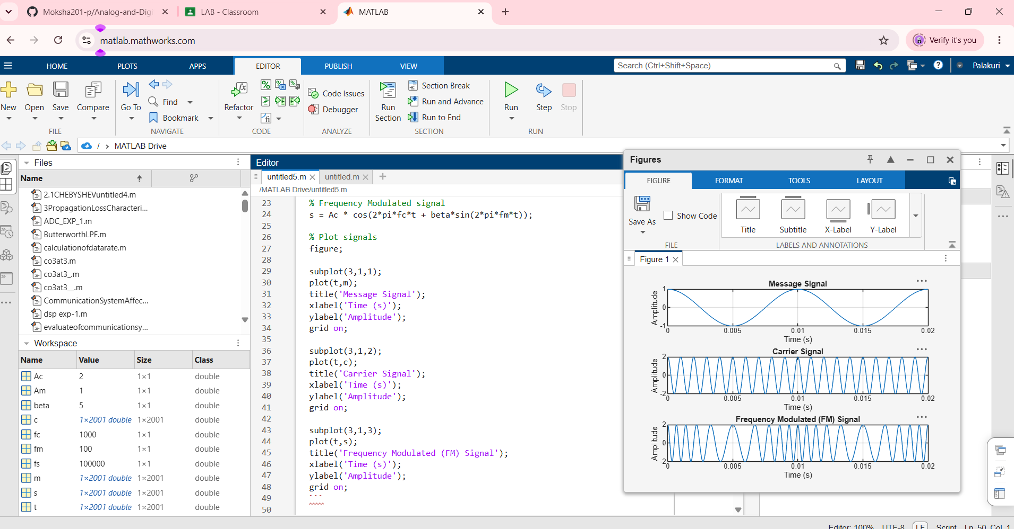
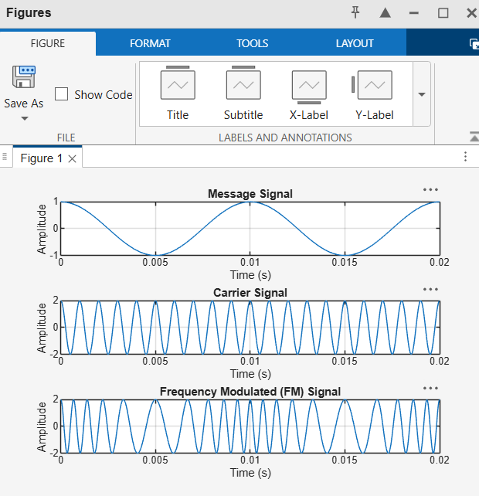
OBJECTIVE:
2. To calculate and verify the frequency deviation of the FM signal from the given carrier
frequency and modulating signal parameters.
PROGRAMMING CODE:
clc;
clear;
close all;

% Given Parameters
Am = 1; % Message signal amplitude
Ac = 2; % Carrier signal amplitude
fm = 100; % Message frequency in Hz
fc = 1000; % Carrier frequency in Hz
kf = 500; % Frequency sensitivity in Hz/V

% Calculate Frequency Deviation
delta_f = kf * Am;

% Display Results
fprintf('Carrier Frequency = %d Hz\n', fc);
fprintf('Message Frequency = %d Hz\n', fm);
fprintf('Frequency Sensitivity = %d Hz/V\n', kf);
fprintf('Maximum Frequency Deviation = %d Hz\n', delta_f);

% Time Vector
fs = 100000;
t = 0:1/fs:0.05;

% Generate Message Signal
m = Am * cos(2*pi*fm*t);

% Generate FM Signal
s = Ac * cos(2*pi*fc*t + 2*pi*kf*Am/(2*pi*fm)*sin(2*pi*fm*t));

% Calculate Instantaneous Frequency
f_inst = fc + kf * m;

% Plot Message Signal
figure;

subplot(3,1,1);
plot(t,m);
title('Message Signal');
xlabel('Time (s)');
ylabel('Amplitude');
grid on;

% Plot FM Signal
subplot(3,1,2);
plot(t,s);
title('Frequency Modulated Signal');
xlabel('Time (s)');
ylabel('Amplitude');
grid on;

% Plot Instantaneous Frequency
subplot(3,1,3);
plot(t,f_inst);
title('Instantaneous Frequency of FM Signal');
xlabel('Time (s)');
ylabel('Frequency (Hz)');
grid on;

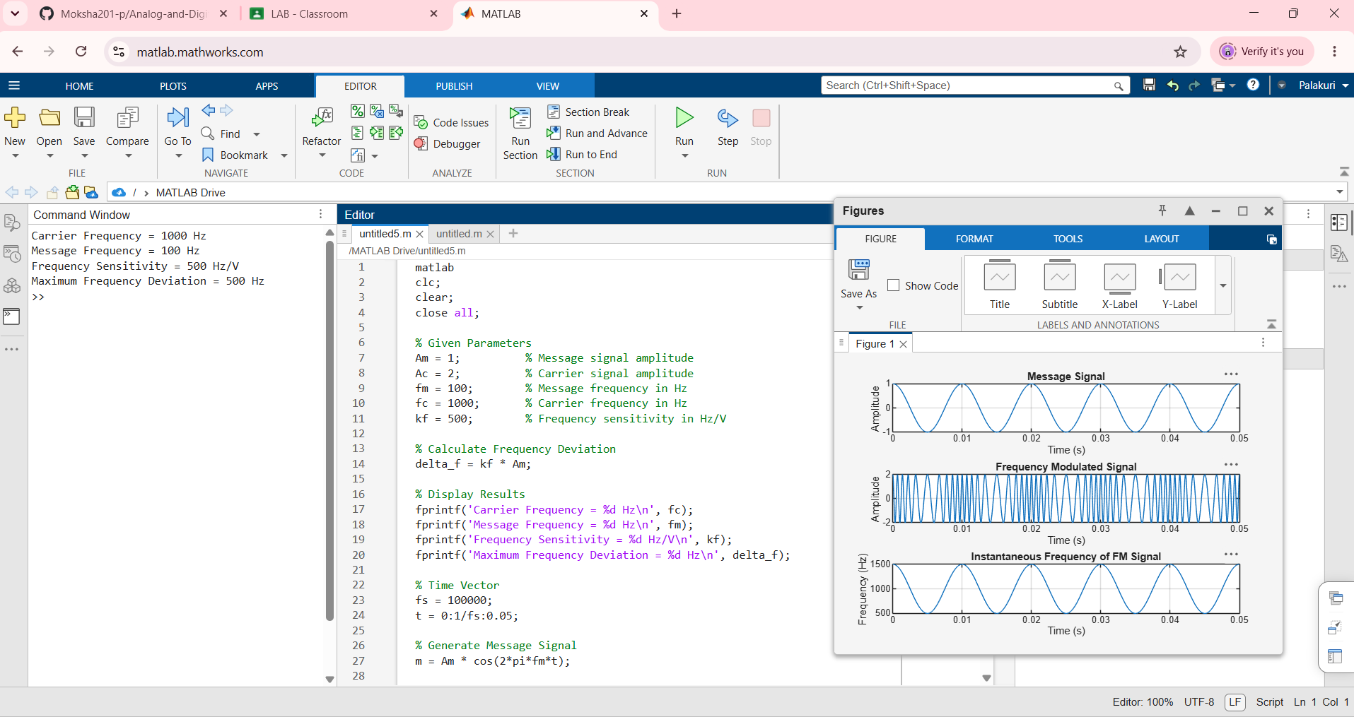
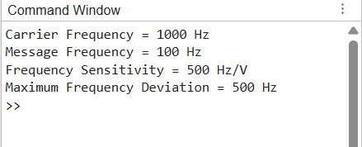
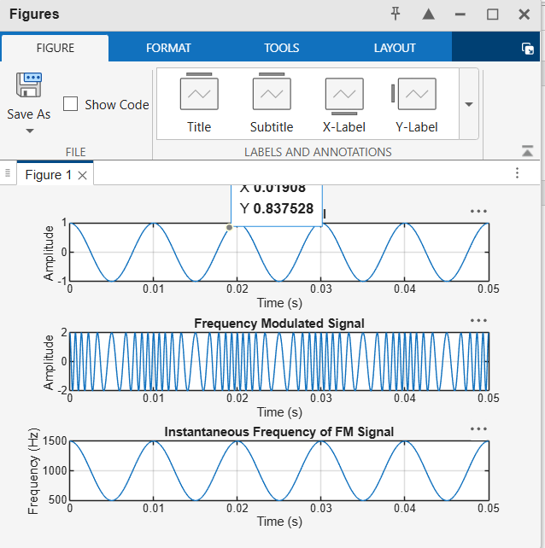

OBJECTIVE:
3. To determine and verify the modulation index of the FM signal using the relationship
between frequency deviation and message frequency.
PROGRAMMING CODE:
clc;
clear;
close all;

% Given Parameters
Am = 1; % Message signal amplitude
Ac = 2; % Carrier signal amplitude
fm = 100; % Message frequency in Hz
fc = 1000; % Carrier frequency in Hz
kf = 500; % Frequency sensitivity in Hz/V

% Calculate Frequency Deviation
delta_f = kf * Am;

% Calculate Modulation Index
beta = delta_f / fm;

% Display Results
fprintf('Carrier Frequency = %d Hz\n', fc);
fprintf('Message Frequency = %d Hz\n', fm);
fprintf('Maximum Frequency Deviation = %d Hz\n', delta_f);
fprintf('FM Modulation Index = %.2f\n', beta);

% Time Vector
fs = 100000;
t = 0:1/fs:0.05;

% Generate Message Signal
m = Am * cos(2*pi*fm*t);

% Generate Carrier Signal
c = Ac * cos(2*pi*fc*t);

% Generate FM Signal
s = Ac * cos(2*pi*fc*t + beta*sin(2*pi*fm*t));

% Plot Signals
figure;

subplot(3,1,1);
plot(t,m);
title('Message Signal');
xlabel('Time (s)');
ylabel('Amplitude');
grid on;

subplot(3,1,2);
plot(t,c);
title('Carrier Signal');
xlabel('Time (s)');
ylabel('Amplitude');
grid on;

subplot(3,1,3);
plot(t,s);
title('Frequency Modulated Signal');
xlabel('Time (s)');
ylabel('Amplitude');
grid on;

OUTPUT:
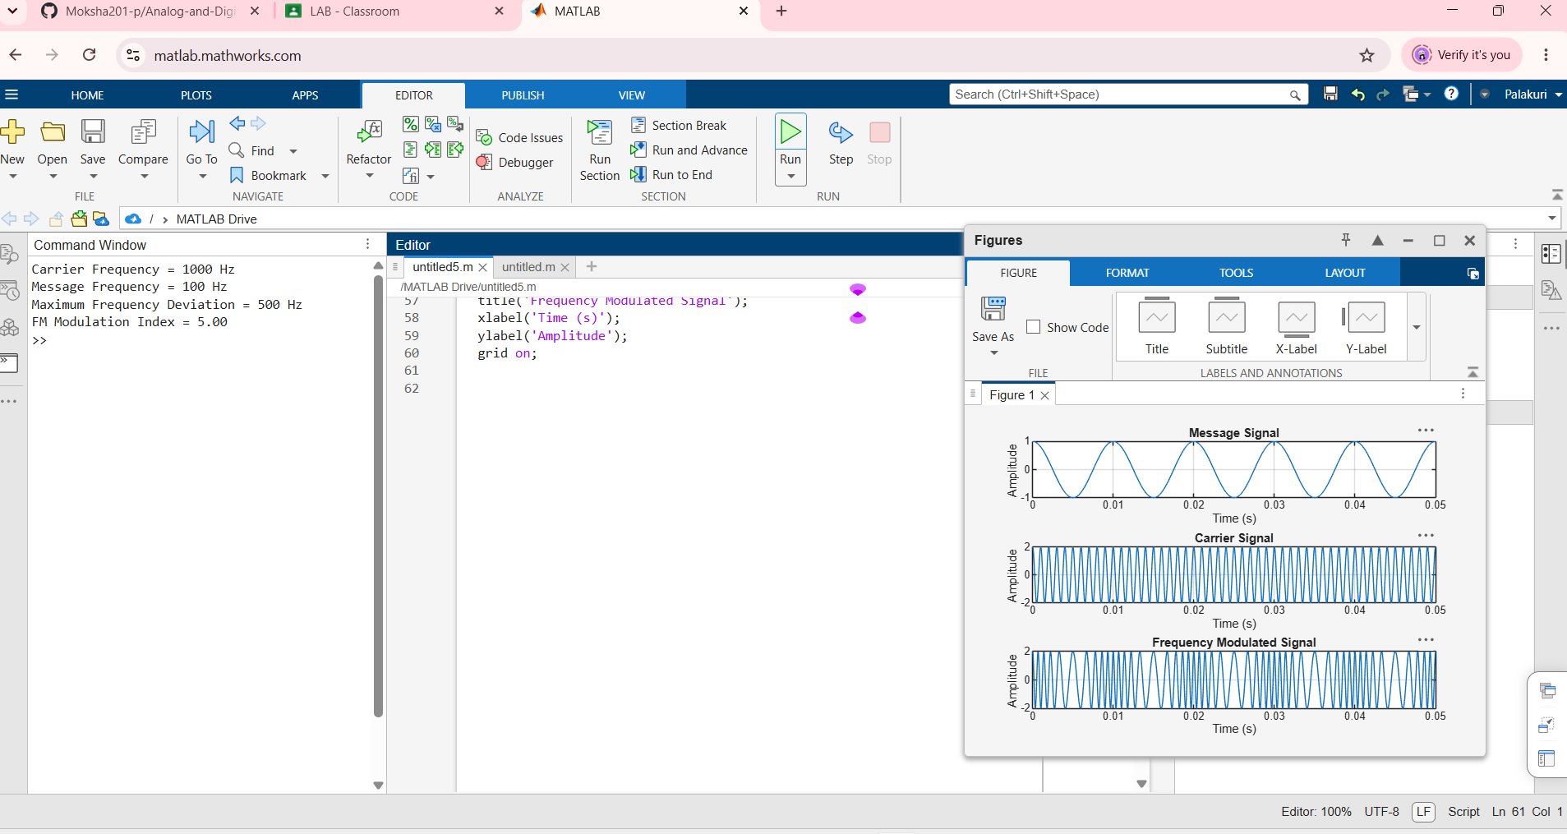
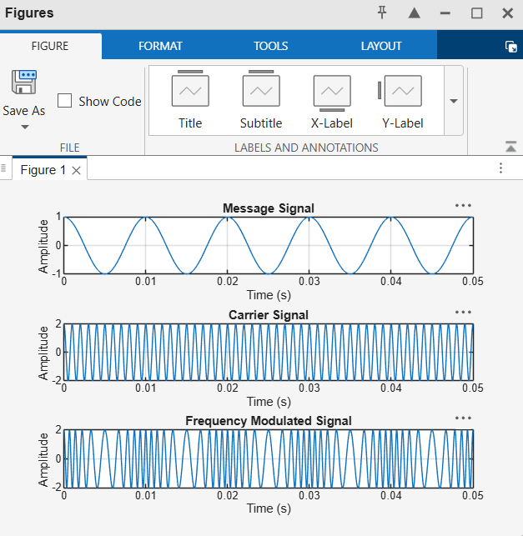

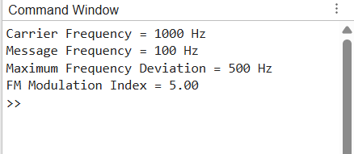

OBJECTIVE:
4. To analyze the effect of message frequency on frequency deviation and modulation
index, and verify their relationship through MATLAB simulation
PROGRAMMING CODE:
clc;
clear;
close all;

% Parameters
Am = 1; % Message signal amplitude
Ac = 2; % Carrier signal amplitude
fc = 1000; % Carrier frequency in Hz
kf = 500; % Frequency sensitivity in Hz/V

% Different message frequencies
fm = [50 100 200 300 400];

% Calculate frequency deviation and modulation index
delta_f = kf * Am * ones(size(fm));
beta = delta_f ./ fm;

% Display results
fprintf('Message Frequency (Hz)\tFrequency Deviation (Hz)\tModulation Index\n');
fprintf('---------------------------------------------------------------\n');

for i = 1:length(fm)
fprintf('%10d\t\t%15.2f\t\t%10.2f\n', ...
fm(i), delta_f(i), beta(i));
end

% Plot frequency deviation
figure;
subplot(2,1,1);
plot(fm, delta_f, 'bo-', 'LineWidth', 2);
title('Message Frequency vs Frequency Deviation');
xlabel('Message Frequency (Hz)');
ylabel('Frequency Deviation (Hz)');
grid on;

% Plot modulation index
subplot(2,1,2);
plot(fm, beta, 'ro-', 'LineWidth', 2);
title('Message Frequency vs Modulation Index');
xlabel('Message Frequency (Hz)');
ylabel('Modulation Index');
grid on;

% Generate FM signals for different message frequencies
fs = 100000;
t = 0:1/fs:0.02;

figure;
for i = 1:length(fm)
beta_i = delta_f(i) / fm(i);
s = Ac * cos(2*pi*fc*t + beta_i*sin(2*pi*fm(i)*t));

subplot(length(fm),1,i);
plot(t,s);
title(['FM Signal for Message Frequency = ', num2str(fm(i)), ' Hz']);
xlabel('Time (s)');
ylabel('Amplitude');
grid on;
end
OUTPUT:
